Building Regulation Application
Gloucestershire Building Control Group

THE BUILDING ACT 1984
THE BUILDING REGULATIONS 2010

REGULARISATION OF UNAUTHORISED WORK
(For unauthorised building works carried out on or after 11th November 1985)

 |  | PLEASE TYPE OR USE BLOCK CAPITALS
1 |  | Address where building work has been carried out
 |  | Address:
 |  |  |  |  |  |  |  |  |  |  |  |  |  |  |  |  |  |  |  |  | Postcode:
 |  | Note: A location plan sufficient to readily identify the site should be included
2 |  | Full description of unauthorised work (e.g. single storey extension to enlarge the lounge)
3 |  | Date when work commenced:
4 |  | Applicant’s details (please give FULL name, postal address and contact details)
 |  | Mr/Mrs/Ms/Miss:
 |  | Address:
 |  |  |  |  |  |  |  |  |  |  |  |  |  |  |  |  |  |  |  |  | Postcode:
 |  | Email: |  |  |  |  |  |  |  |  |  |  |  |  |  |  |  |  |  |  | Tel:
5 |  | Agent’s details (if applicable, please give details of the person dealing with the project e.g architect, surveyor)
 |  | Company: |  |  |  |  |  |  |  |  |  |  |  |  |  |  | Contact Name:
 |  | Address:
 |  |  |  |  |  |  |  |  |  |  |  |  |  |  |  |  |  |  |  |  | Postcode:
 |  | Email: |  |  |  |  |  |  |  |  |  |  |  |  |  |  |  |  |  |  | Tel:
6 |  | Where change of use has occurred
 |  | Present use of building:
 |  | Previous use of building:
7 |  | Plans of regularisation works |  |  |  |  |  |  |  |  |  |  |  |  |  |  |  |  |  |  |  |  |  |  |  |  |  |  | YES NO
8 |  | Mode of drainage and water supply (e.g. to an existing mains sewer or to a new treatment plant)
 |  | Foul Water: |  |  |  |  |  |  |  |  |  |  |  |  |  |  |  |  | New Existing |  |  |  |  |  |  |  |  |  |  |  | (please specify)
 |  | Surface Water: |  |  |  |  |  |  |  |  |  |  |  |  |  |  |  |  | New Existing |  |  |  |  |  |  |  |  |  |  |  | (please specify)
 |  | Water Supply: |  |  |  | Mains |  |  |  | Other: |  |  |  |  |  |  |  |  |  |  |  |  |  |  |  |  |  |  |  |  | (please specify)
9 |  | Planning Permission
 |  | Have proposals been subject to a Planning application? |  |  |  |  |  |  |  |  |  |  |  |  |  |  |  |  |  |  |  |  |  |  |  |  |  |  |  | YES NO
 |  | If yes, what is the application reference number?
 |  | FEES (please see the accompanying fee schedule for the appropriate Council)
 |  | Please note that VAT is not payable on Regularisation applications
10 |  | Schedule 1 |  |  | Erection of new dwellings up to 3 storeys & not more than 300m² in floor area
 |  | Was the development funded: |  |  |  |  |  |  | Privately |  |  |  |  |  |  |  | Housing Association |  |  |  |  |  |  |  |  |  |  | Local Authority
 |  |  |  |  | Number of Dwellings:
 |  |  |  |  |  |  |  |  |  |  |  |  |  |  |  |  |  |  |  |  | Fee due: |  |  |  |  |  |  |  |  |  |  | £
 |  |  |  |  | Internal floor area: |  |  |  |  |  |  |  |  |  |  |  |  |  |  | m² |  |  |  |  |  |  |  |  |  |  |  | £
11 |  | Schedule 2 |  |  | Domestic extensions, loft conversions & garages/carports
 |  |  |  |  | Garage/carport internal floor area: |  |  |  |  |  |  |  |  |  |  |  |  |  |  |  |  | m² |  | Fee due: |  |  |  |  |  |  |  | £
 |  |  |  |  | Extension internal floor area: |  |  |  |  |  |  |  |  |  |  |  |  |  |  |  |  | m² |  | Fee due: |  |  |  |  |  |  |  | £
 |  |  |  |  | Garage conversion: |  |  |  |  |  |  |  |  |  |  |  |  |  |  |  |  | m² |  | Fee due: |  |  |  |  |  |  |  | £
 |  |  |  |  | (For floor areas over 100m² please use Schedule 3)
12 |  | Schedule 3 |  |  | Other works based on estimated cost
 |  |  |  |  | Estimated cost (excluding vat): |  |  |  |  |  |  |  |  |  |  | £ |  |  |  |  |  |  |  | Fee due: |  |  |  |  |  |  |  | £
 |  |  |  |  | (You may be required to provide an estimate)
13 |  | Schedule 4 |  |  | Installation of solar or PV panels |  |  |  |  |  |  |  |  |  |  |  | Fee due: |  |  |  |  |  |  |  |  |  |  |  |  |  |  | £
 |  |  |  |  | Replacement doors/windows |  |  |  |  |  |  |  |  |  |  |  |  |  |  |  | Fee due: |  |  |  |  |  |  |  |  |  |  | £
14 |  | Statement
 |  | I confirm that this application is submitted in accordance with Regulation 18(2) and I seek a Regularisation Certificate in respect of the unauthorised works described under 2 above.
 |  | Signed: |  |  |  |  |  |  |  |  |  | Name: |  |  |  |  |  |  |  |  |  |  |  |  |  | Date:

IMPORTANT INFORMATION

Please note you may be requested to expose areas of work to enable inspections to be made

For further advice on Building Regulation matters please contact your local Building Control Service

 |  | Cheltenham AND Tewkesbury Building Control Service – Situated at Cheltenham  ALL CHEQUE TO BE PAYABLE TO CHELTENHAM BOROUGH COUNCIL  Built Environment, Municipal Offices, Promenade, Cheltenham, Glos, GL50 1PP
 |  | Tel: 01242 264321  01242 264390 |  |  | Fax: 01242 227323 | Email: buildingcontrol@cheltenham.gov.uk
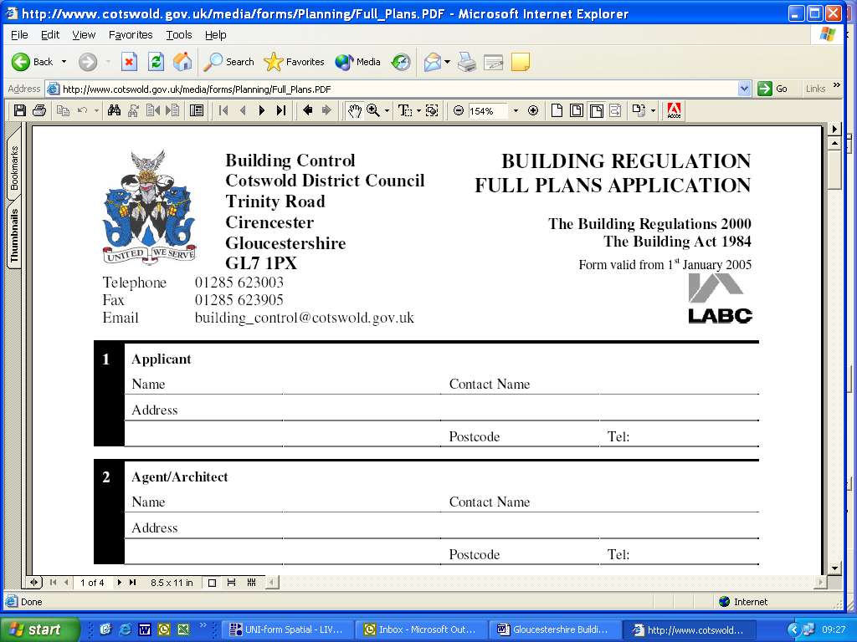 |  |  | Cotswold District Council  Building Control, Trinity Road, Cirencester, Glos, GL7 1PX
 |  |  | Tel: 01285 623000 |  | Fax: 01285 653905 | Email: buildingcontrol@cotswold.gov.uk
 |  |  | Forest of Dean District Council  Building Control Services, Council Offices, High Street, Coleford, Glos, GL16 8HG
 |  |  | Tel: 01594 810000 |  | Fax: 01594 812353 | Email: building.control@fdean.gov.uk
Gloucestershire Building Control Partnership

For charges please see charges information sheet
Gloucestershire Building Control Partnership, Ebley Mill, Ebley Wharf, Stroud, Glos, GL5 4UB
 |  |  |  |  | Email: building.control@stroud.gov.uk

Updated: May 2020

